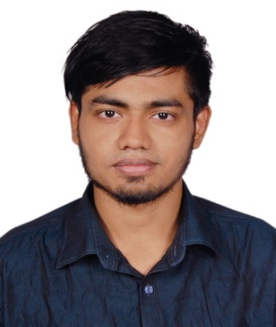

Md. Abdullah Al Samad
75- A/B, Second Colony, Boishakhi Road,
Mirpur-1, Dhaka 1216,
Contact No. +880 1891715651
Email: mdsam.raian@gmail.com

CAREER OBJECTIVE
Seeking a position in a dynamic organization where I can launch my career and work towards building a strong skill set.
RELEVENT EXPERIENCE
Video Editor & Digital Content Executive – Creative Agency (Current)
- Manage and review digital content before publishing on social media platforms
- Coordinate with team members to ensure brand consistency and content accuracy
- Handle revisions based on client feedback and platform requirements
Assistant Manager – Aleya Enterprise (2018–2021)
- Communicated with customers and dealers via phone and online platforms
- Handled order processing, basic record keeping, and issue resolution
- Maintained professional communication and customer satisfaction

SOCIAL MEDIA & MODERATION SKILLS
- Responding to customer messages and comments professionally
- Monitoring inbox, comments, and post interactions
- Identifying and handling spam, inappropriate content, and fake inquiries
- Following page rules, shop policies, and platform guidelines

TECHNICAL & DIGITAL SKILLS
- Facebook Page & Messenger handling
- Basic understanding of Facebook Shop workflows
- Content review and moderation
- Basic image/video handling

SOFT SKILLS
- Clear written communication (English & Bangla)
- Patience and customer-focused mindset
- Attention to detail
- Ability to work independently and in a team
- Time management and reliability

EDUCATION
B.Sc. in Electrical & Electronic Engineering (EEE)
United International University (UIU)
CGPA: 3.06 / 4.00

EDUCATION
Available for full-time or shift-based work, including evenings and weekends.

