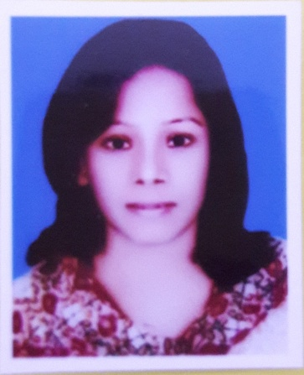

Resume
Of
Amena Akter Asma
C/O MD. Abul Kalam
House No: 30, Road No:9, Block: New-C,
Mirpur-1, Dhaka-1216
Mobile: +8801970040716
Email: asma74582@gmail.com
CAREER OBJECTIVE:
Interested in dynamic, innovative, challenging, customer service and customer communication oriented jobs in national or multinational organization to enrich my career where I will be able to apply all skills.

DURATION OF PREVIOUS JOB EXPERIENE:
1 Year Special Qualifications:
- Flexible and adapt easily to new situation.
- Able to work hard under pressure.
- Good managerial ability.
- Leadership ability in teamwork.
- Strong interpersonal communicational skills.
Employment History:

1) VIVO YuYouQi Mobile (BD) Co Ltd.
- Designation : Vivo Brand Adviser
- Job Location : Bashundhara Shopping Complex, Dhaka.
- Job period : 26-July-2019 to 20-July-2022
Duties / Major Responsibilities:
- Making good relation with channel customer availability and Sales
- To set plan and achieve the monthly business target through an effective management system.
- Handling the customer complain and customer service
- To organize, train; motivate a strong and effective sales team.

3) Digicon Technologies Limited
- Designation : Customer Service Representative
- Reporting To: Team Leader
- Job Location: Mirpur-12
- Job period : 07-April-2023 to 29-February-2024

4) Deximpo International Ltd.
- Designation : Home Moderator
- Reporting To: Team Manager
- Job location: Eastern Plaza Commercial Complex
- Job period : running

Academic Qualification:
Name of Examination | Group | Institute | Passing Year | Result
H.S.C | Business Studies | Alhera Collage (Dhaka Board) | 2019 | GPA 4.30
S.S.C | Business Studies | Kollyanpur Girls School & Collage  (Dhaka Board) | 2017 | GPA 4.50
BBA | Marketing | Bangabandhu College, Mirpur, Dhaka. | Running

Skills:
- Digital Marketing

Computer Knowledge:
- Capable to operating micro soft MS world, MS XL, PowerPoint, Internet browsing, E-mailing. Bangle & English Typing.

Language Proficiency:
- Bangle and English reading, writing and speaking ability is good.

Personal Details :
Father’s Name : MD. Abul Kalam.
Mother’s name : Nur Begum.
Present Address : Boilapur bus stand, Savar.
Permanent Address : House No: 30, Road No: 9, Block: New-C, Shah Ali Mirpur-1, Dhaka-1216.
Date of Birth : 28th April 2000.
Religion : Islam.
Nationality : Bangladeshi by birth.
Marital Status :Married.
Blood group : A+

Signature

Date:…………

