

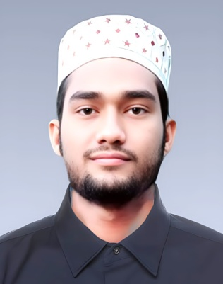

MD Sabbir Ahamed
+8801874066614
Email: mdsabbir018595@gmail.com

Objectives: | would like to be integral part of a well-structured organization by utilizing my knowledge, skill and proper training provided by the organization and l wantto achieve my carrier objective through hard-working, integrity and sincerity.

Academic Qualifications:
Diploma In Engineering (Electrical)
Name of Institute : CCN Polytechnic Institute, Cumilla.
Passing year : Running (6th)
Department : Electrical
Result : Running (6th)
Board : Bangladesh Technical Education Board (BTEB)

Secondary School Certificate Examination (S.S.C)
Name of Institute : Hanif Sarker High School
Passing year : 2022
Group : Science
Result : 4.56
Board : Cumilla
Language Proficiency:
Bengali (Native)
English

Computer Proficiency/Skills:
Have good command of MS Word.
Electrical Installation and Maintenance (Level-1&2)
Consumer Electronics (Level-1)

Area of Interests:
Reading Book, Traveling etc.
Participating in development and social activities.

Personal Details:
Name : MD Sabbir Ahamed
Father's Name : Mohammad Tofayel Ahmed
Mother's Name : Sahana Akter
Permanent Address : Vill: Tanki, P.O: Tanki,
P.S: Muradnagar Dist: Cumilla.
Present Address : Vill: Gondhomoti P.O: Kotbari,
P.S: Sadar South, Dist: Cumilla.
Date of Birth : 1st February 2006
Nationality : Bangladeshi (By birth)
NID : 6929229778
Religion : Islam
Height : 5'-10"
Blood Group : B+(ve)
Marital Status : Single
Home District : Cumilla.

Declaration:
I do hereby declare that all information here is true to my self knowledge. I required & where applicable. This document can be supported by appropriate authentic Certificates/Papers.

Signature
Date:

