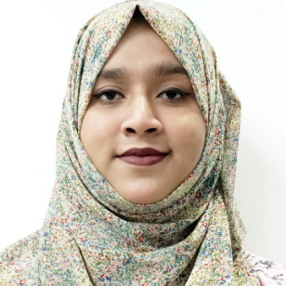  Tahia Binte Alam Tara  Executive-Tele Counselling & Admisson Department  Address  Chittagong, 4202 BD  Phone  01843827058  E-mail  tahiatara385@gmail.com | Dynamic professional with a proven track record at Creative IT Institute, excelling in customer relations and team leadership. Recognized for enhancing client satisfaction and driving sales growth through innovative problem resolution. Adept at leveraging sales analysis to identify opportunities, fostering long-term relationships, and mentoring future leaders.  Work History  Education
  Contact
  Skills
  Customer relations
  Team leadership
  Administrative skills
  Sales analysis
  Computer Literacy
  Problem resolution
  Languages
  English
  11 months
   | 2024-10 - Current |  | Executive-Tele Counselling and Admisson Department  Creative IT Institute, Chittagong, Bangladesh  - Established long-term client relationships through consistent delivery of high-quality products and services.  - Enhanced customer satisfaction by streamlining communication channels and improving response times.  - Developed innovative solutions to complex problems, resulting in improved organizational performance.  - Mentored junior staff members for accelerated career growth, developing future leaders within the organization.
  5 months
   | 2024-05 - 2024-09 |  | Sales Associate  Gsis Academy, Chittagong, Bangladesh
  4 years
   | 2020-01 - 2023-12 |  | Sales Representative & Marketing Team Cordinator  GMIT INSTITUTE, Chittagong, Bangladesh  - Expanded customer base through cold calling, networking, and relationship building.  - Enhanced client satisfaction by addressing concerns promptly and providing exceptional service.  - Increased sales revenue by identifying and targeting high-potential accounts.  - Proven Sales Leadership – Led a high-performing team, consistently meeting and surpassing sales goals.  - Generated additional sales opportunities with upselling and cross-selling techniques.
   | 2025-01 |  | High School Diploma  Chittagong Polytechnic Institute - Chittagong
   | 2019-02 |  | Associate of Science: SSC  Rangunia M.M.P High School - Chittagong, Bangladesh
.
#HRJ#89ffd8ff-7f48-4a65-8da0-e5409b2c6811#

